JAVA ASSIGNMENT 7

1)Write a program called SumProductMinMax3 that prompts user for three integers. The program shall read the inputs as int; compute the sum, product, minimum and maximum of the three integers; and print the results

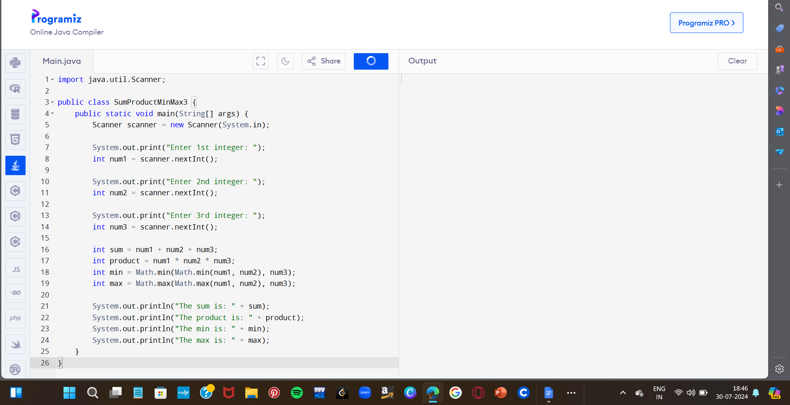

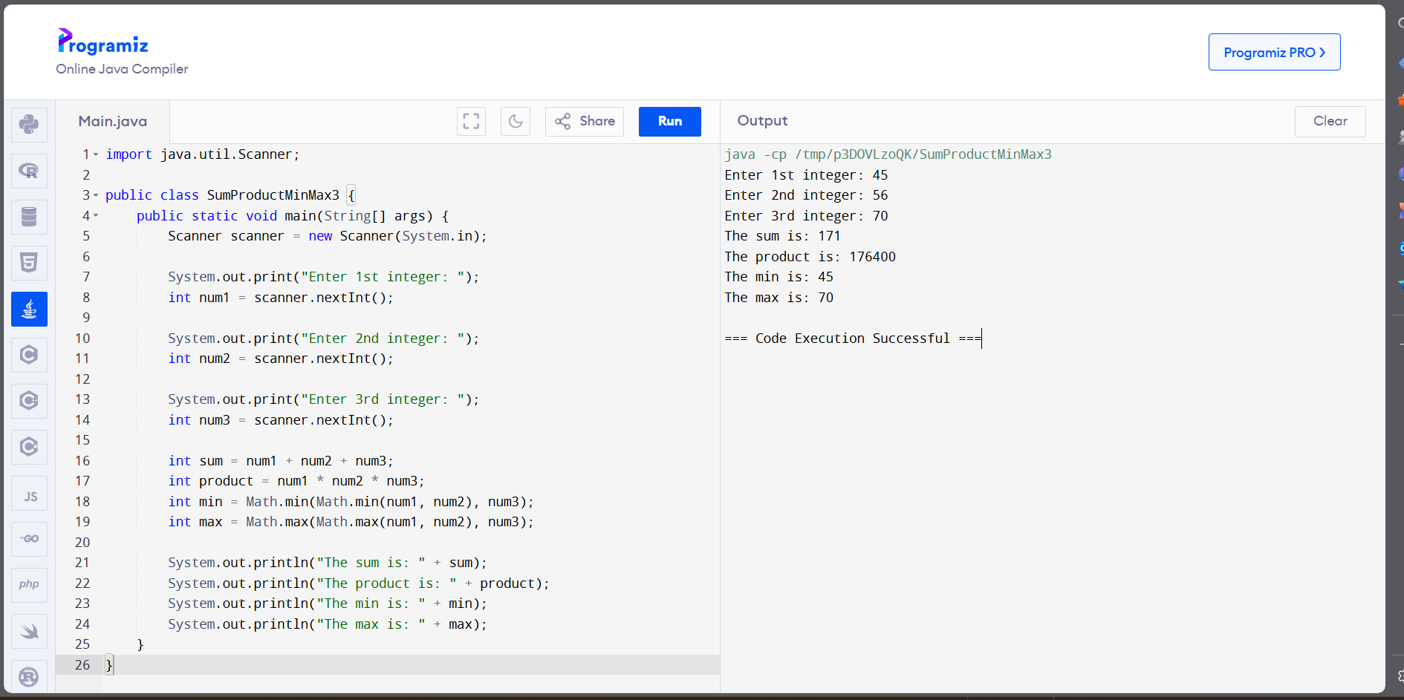

2)Calculate BMI Using Java

The user enters his height (in inches) and weight (in pounds). The variables passed by the user are assigned to the float type. After calculating the BMI value, the value will be assigned to the appropriate range and the correct message will appear on the console. You can use the if-else-if ladder for printing the message on the console.

Intervals of BMI index:

16.00 or less = starvation

16.00-16.99 = emaciation

17.00-18.49 = underweight

18.50-22.99 = normal, low range

23.00-24.99 = normal high range

25.00-27.49 = overweight low range

27.50-29.99 = overweight high range

30.00-34.99 = 1st degree obesity

35.00-39.99 = 2nd degree obesity

40.00 or above = 3rd degree obesity

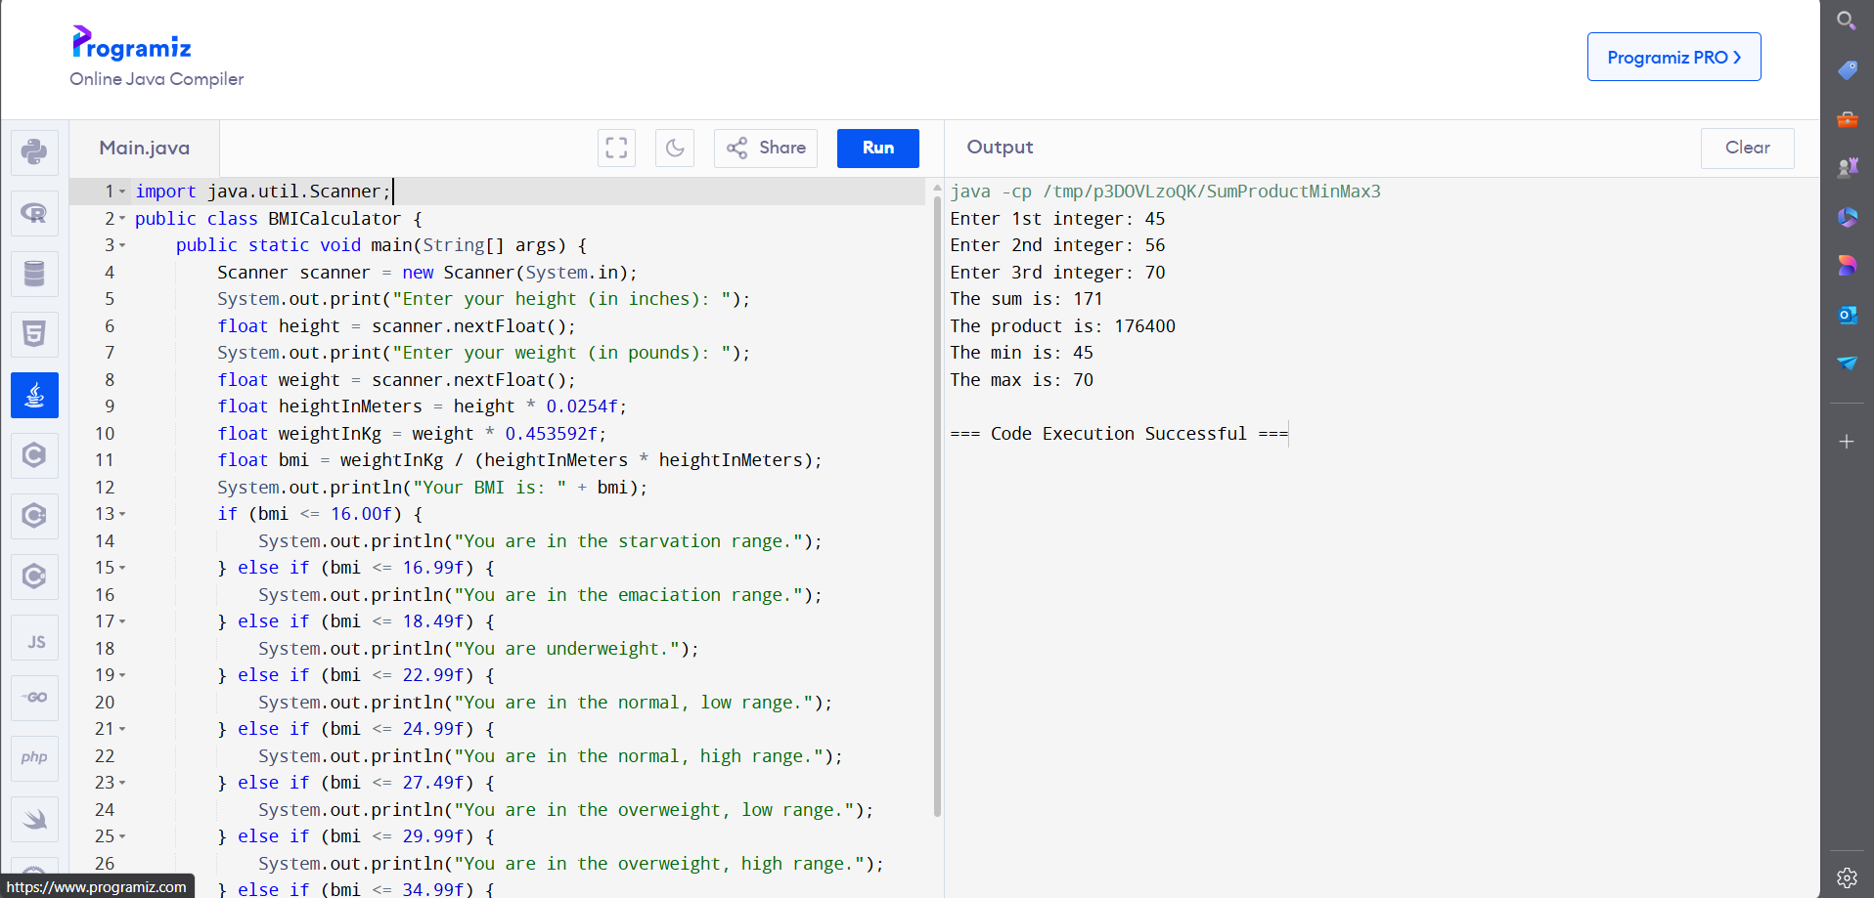

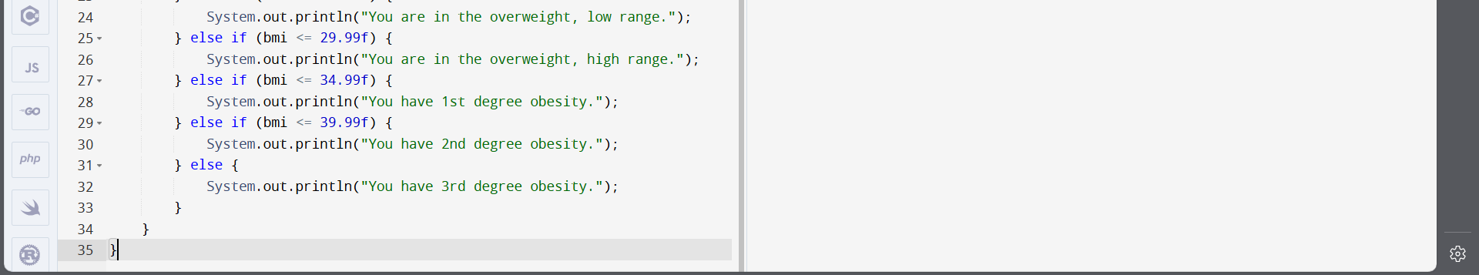

OUTPUT:

